MEMORIAL HERMANN IRONMAN TEXAS - MAY 21, 2011
Beth Lamie, Coach, Pegasus Elite Triathlon Team

THE DAY BEFORE THE RACE

Unlike our trip to Texas last month, where we spent 10 days in the state, this trip would be a whirlwind. We arrived in Houston Thursday afternoon, rented a car (not a Uhaul this time) and headed up to the Woodlands - a planned community an hour north of Houston. We checked into the La Quinta, unpacked and put Mike's bike together, and headed out to packet pick-up/registration. There was no packet pick-up the day before the race (Friday), so the line was HUGE. I waited in line, while Mike went to have his bike checked by the bike mechanic. Mike had been having trouble with his (Tim's) Zipp 404 rear wheel ever since his race in Galveston the month before and he wanted to have the mechanic check it out.

While I waited in line, I listened to the conversations of nervous/excited triathletes and the big discussion was whether it would be a wetsuit swim or not. It was billed as non-wetsuit legal, but the water temp had been dropping (hmmmm…) and it seemed as though it was going to be cool enough to allow the wetsuit 'optional' rule (it's not so warm the wetsuits will be forbidden, but too warm for wetsuit mandatory/legal. So if you chose to wear one, you take yourself out of contention for awards or Kona slot).

When Mike had dropped the bike off and had gotten back in line, he and I discussed the idea of using the full disk on the rear. The course was windy, but not like Kona (or even Galveston) where it's wide open and the gusts can be outrageous. Mike's a pretty big guy (170 lbs race weight) so he doesn't get airborne on the bike like I would in a cross wind with a disk, so we decided that since he was iffy about the Zipp 404 and he could handle the disk, that would be the way to go.

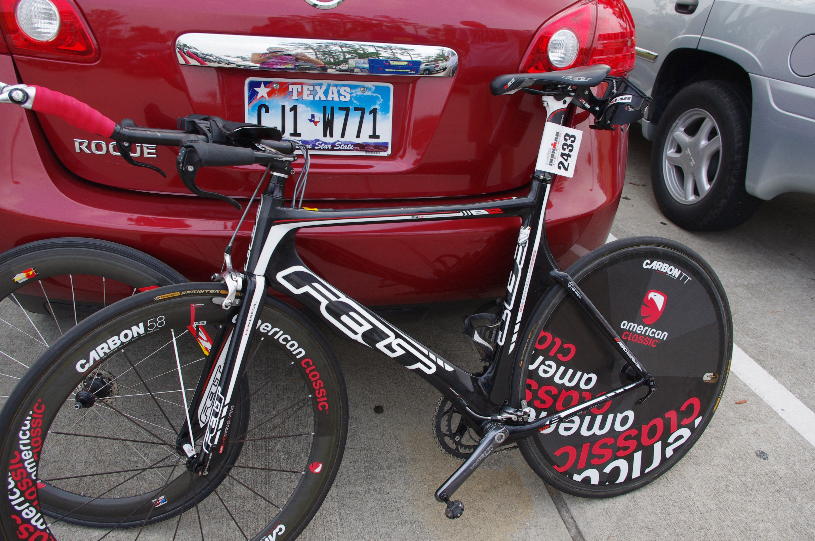

We grabbed dinner at a great Asian stir-fry place (LOADS of rice, noodles and vegetables), checked out the course some more, and then headed over to the athletes' meeting. The meeting was pretty much standard fare, and no more light was shed on the wetsuit situation. At these meetings, everyone is always dressed in their Ironman 'uniform': compression socks, shorts, Oakley's on the head, a Livestrong bracelet, and of course, wearing their most impressive race T-shirt. I love the shirt Mike chose to wear - a gift from one of my clients who is "in sandpaper" …..
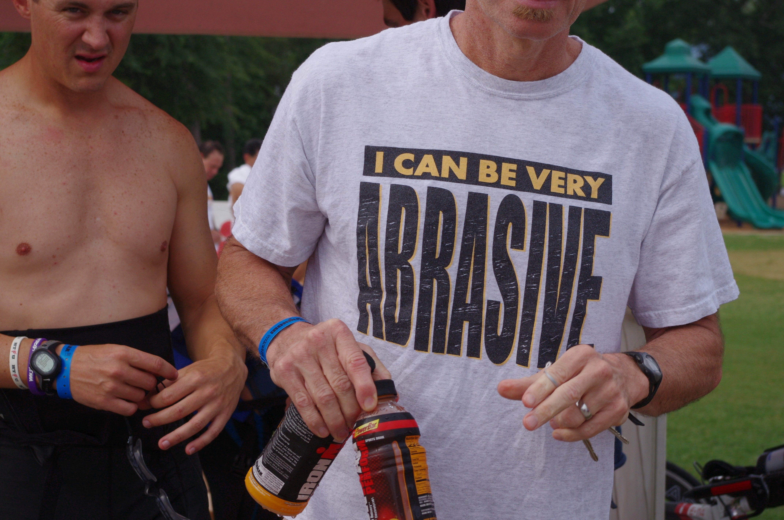

After the meeting, we made a quick stop for groceries at a very cool gourmet store and got back to the hotel by 8:30 pm for early bed.

The next morning - the day before the race - was the only day available for a practice swim. Although I normally have my athletes take a complete day off before the race, both Mike and Robert Botard opted for an easy swim just to check the situation out. We were told that most of the swim was no more than 4-feet deep, and we wanted to see if that would present any problems. We also wanted to see if there was any current or any sighting issues beyond the norm.

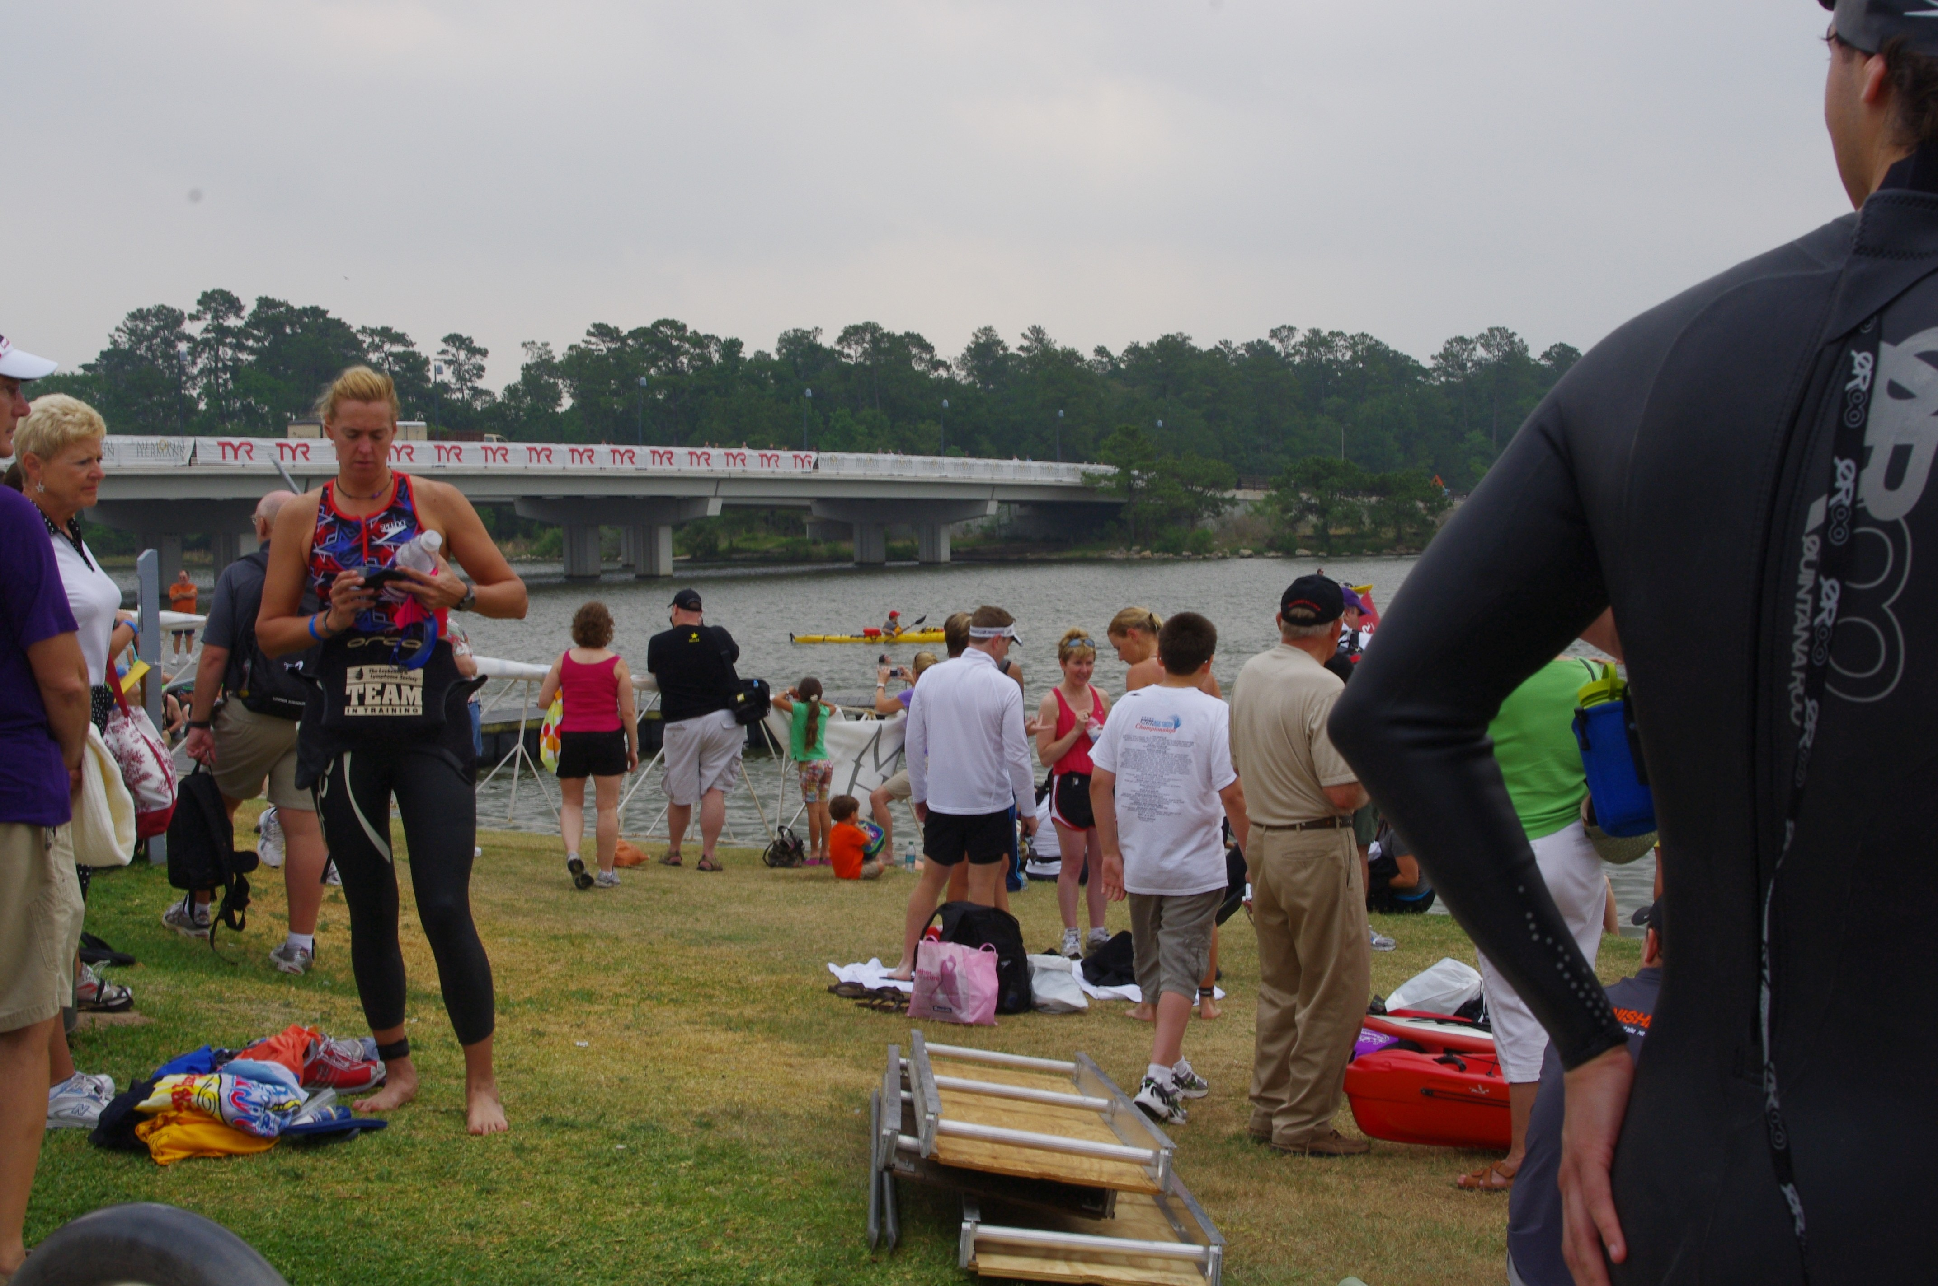

The water has pretty low visibility (like Eagleman or Great Floridian) so sighting frequently was necessary, especially if you were at the front for the start. Also, the swim started in a pretty good sized body of water before it took the swimmers into a narrower canal. There was plenty of opportunity for the race to spread out before entering the canal, so congestion didn't look like it would be a problem.

After the swim, Mike dropped off his bike and race bags, and we met Tina, Christina and Robert at The Black Walnut Café for a yummy, huge, carbo-load breakfast and to discuss race strategy. Breakfast was nice and leisurely and it was a great opportunity for me to really catch up with three of my Texas clients. Also, since it was a first Ironman for Robert, Tina and Christina, I wanted to make sure that they had an opportunity to ask all questions and talk about how they were feeling. A little shared anxiety, lots of laughs, and we were back to the hotels to spend the rest of the day resting. And eating. And drinking!

Mike laid everything for the morning out in piles while I did some more running around (checking out my plan for the race, getting food, working on client schedules). We watched the movie 'Win/Win' and went to bed early.

RACE MORNING

The day started at about 4:30 am when we woke to our alarm at the La Quinta, about 3 miles from the race start. We had both showered and laid everything out the night before so all we had to do was get up, have breakfast and get dressed. The nice thing about an Ironman is that everything is dropped off the day before the race, so there isn’t too much to do in the morning.

The swim start was about a 1 mi walk from transition (and the finish line) so we drove to the finish line, parked the car and Mike went into transition to leave his race food on the bike and check his tires.
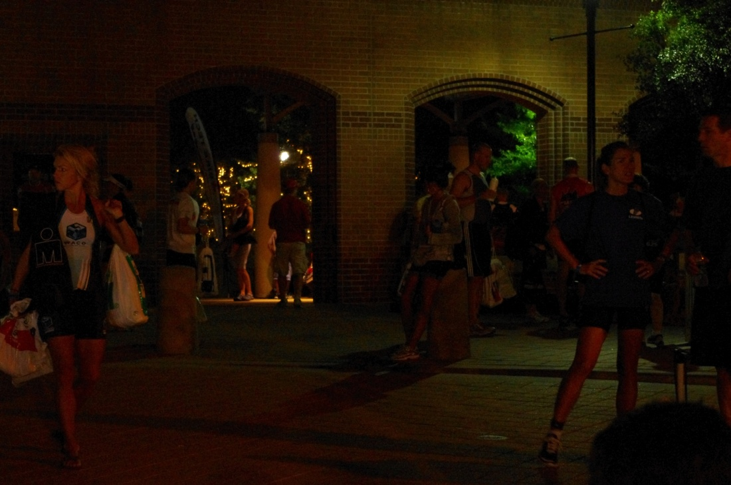

We then began the procession to the swim start. Because the water temperature had been changing throughout the week, we still weren’t sure if the swim would be wetsuit legal, so Mike had his wetsuit with him.

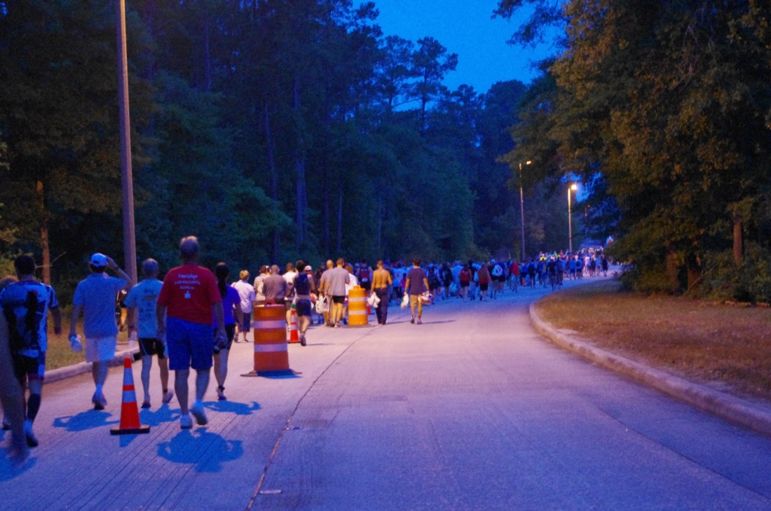

As the sun was coming up, the day was slightly overcast, a little bit misty, and in the 70’s. PERFECT weather for racing!

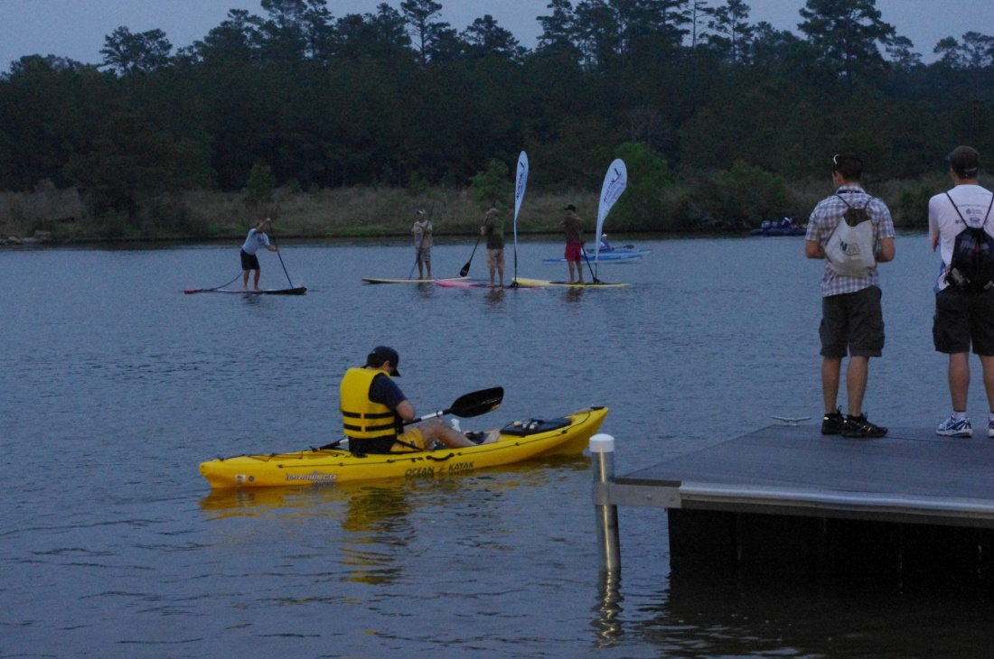

We were told there were 1,700+ 1st timers at this race, so the swim start was bedlam, but we found a quite place and waited to hear the verdict on the wetsuits. Mike’s a very good swimmer, so he was hoping to have a “wetsuit optional” swim (not so warm that wetsuits wouldn’t be allowed, so you could wear one if you weren’t going for the Kona slot) and I was hoping for the same. Christina, Robert and Tina were doing their first Ironman, so I wanted them to be able to wear the wetsuit if they chose to. Pretty soon, we all got our wish….

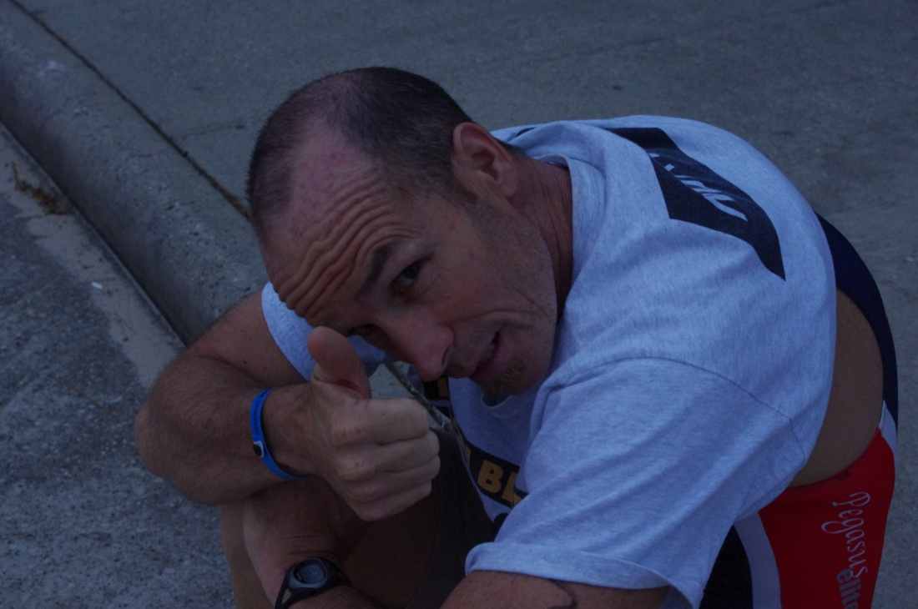

It didn’t look like athletes were going to get a chance to warm up in the water, so Mike went for a quick run to get his heart rate up. By the time he got back, Mike Riley was fired up, screaming at athletes to get in water, but get back before the start line! The pros had a 10 min head start, then the age groupers lined up in separate corrals so that those with wetsuits went over a separate timing mat (Eagleman, take note). As Mike lined up to get into the water, I headed back to the transition/swim finish so I could watch Mike and my other athletes get out of the water and out on the bike.

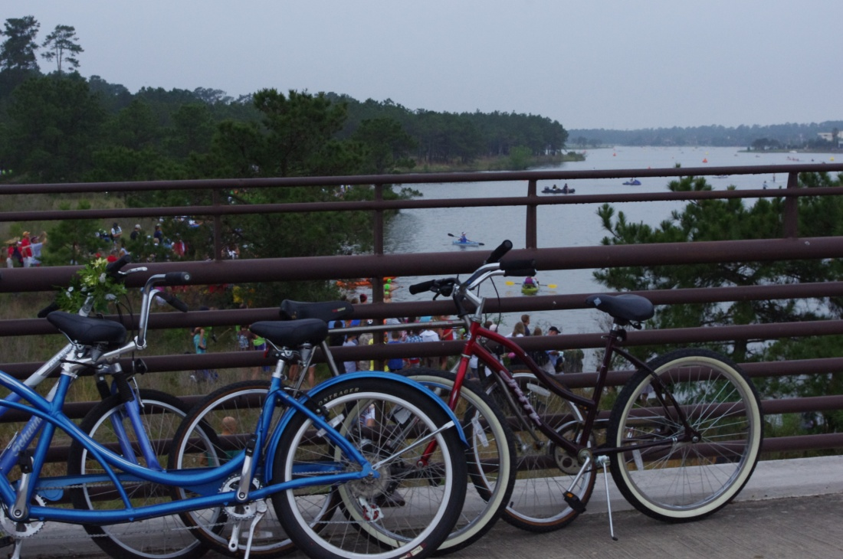

While I was waiting for the athletes to finish the swim, I snapped some great pictures! A lot of people who lived in the area just came out to watch what was going on – even if they didn’t know someone racing. The enthusiasm was amazing. Spectators were lining up everywhere to watch the race. This race is VERY spectator-friendly, and other than when the athletes are gone on the bike, you can get a front-row-center seat to watch the athletes come by.

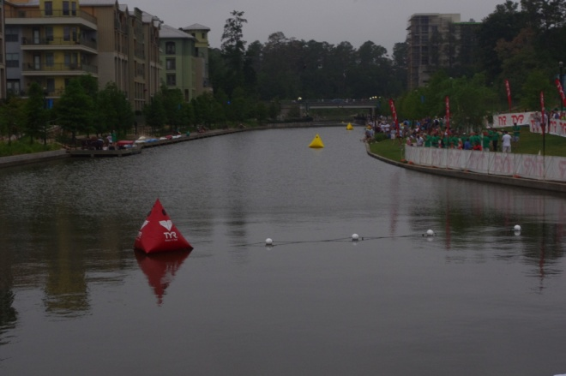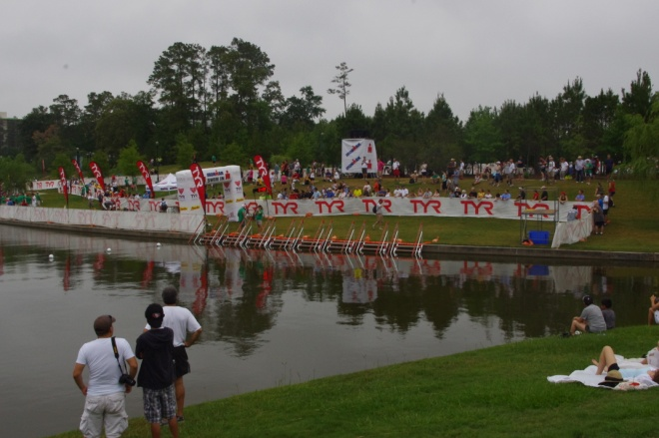

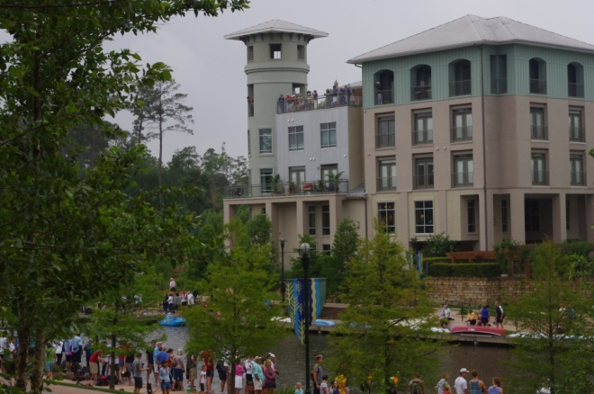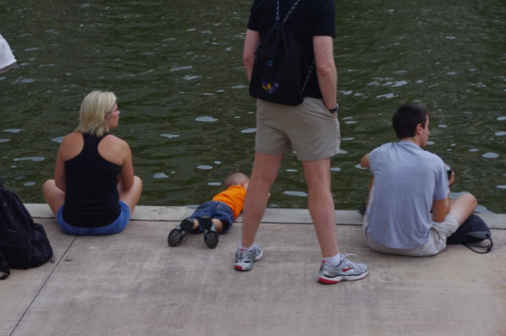

In fact, when the swimmers started coming, they were so close you could wave to them….
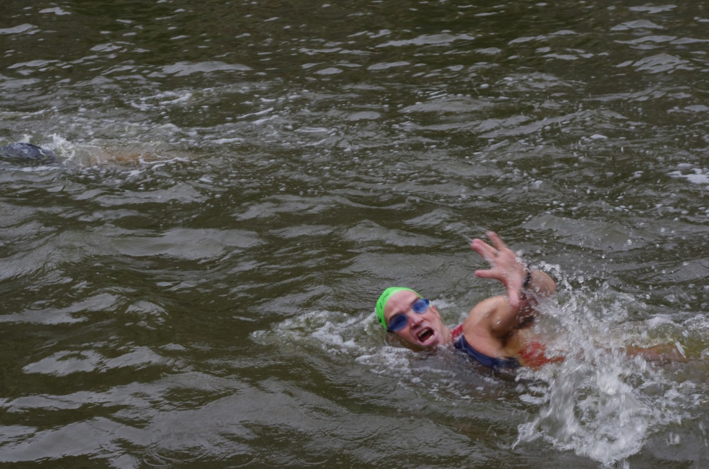

We had come to the Woodlands a month earlier to check out the course, but it still seemed new to me and I wasn't sure I had found the perfect place to watch. However, I soon found my way around and after Mike went by on the swim, I ran up the levy to the bridge over the swim canal and watched Mike go by on the bike……

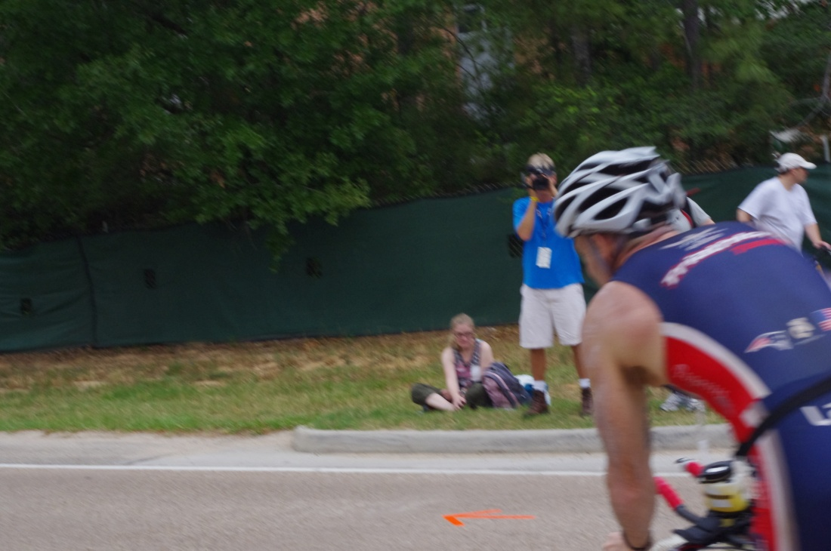

…then went back down the levy and waited for Rob, Christina and Tina to go by…..

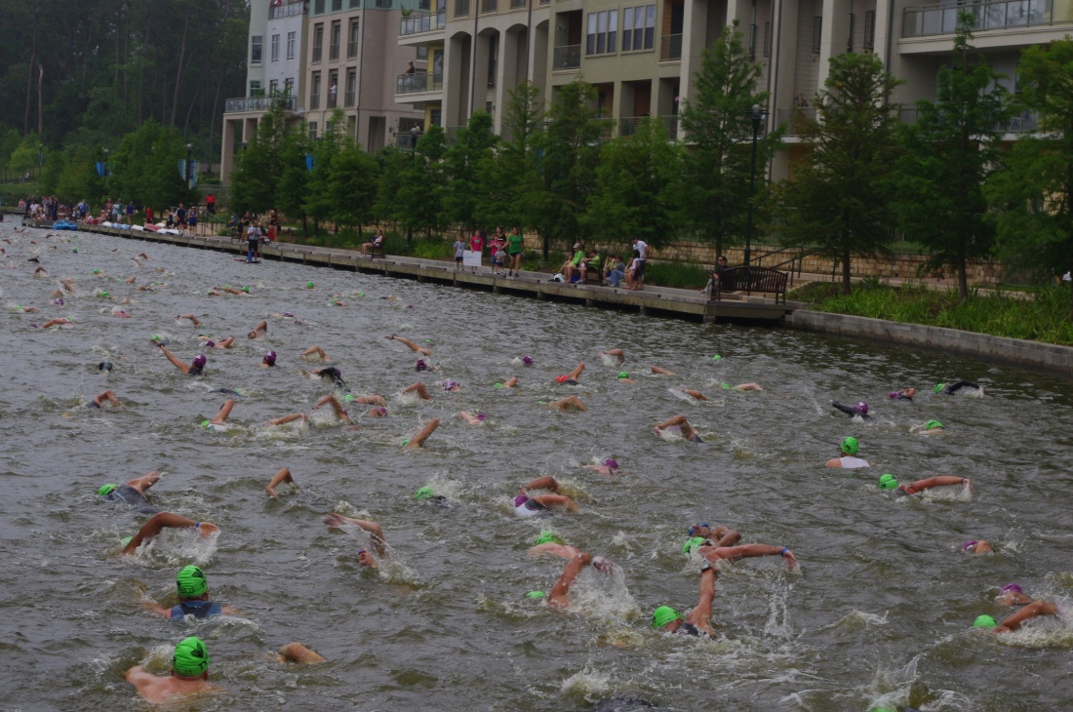

While I was watching, I saw this……
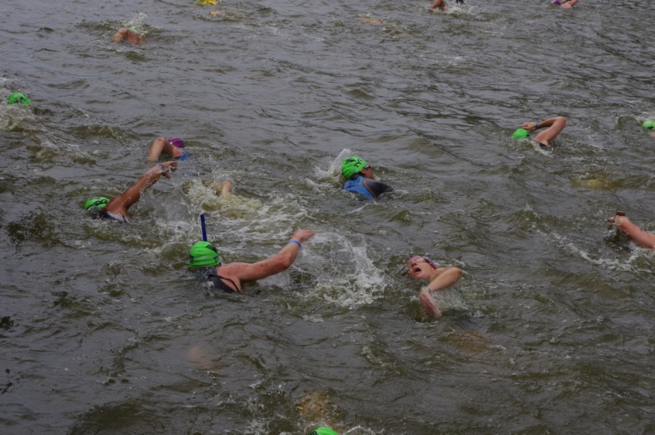

And this …..

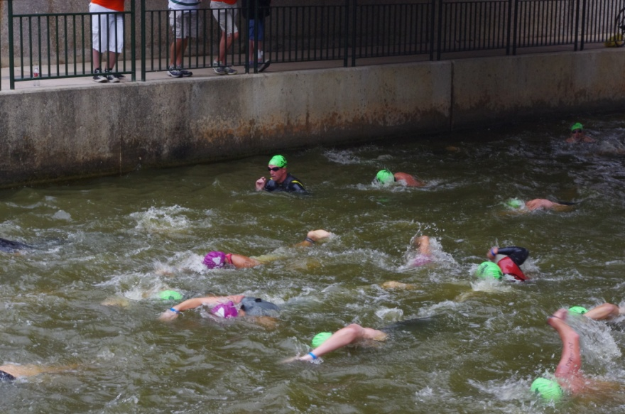

The swim canal is only 4 feet deep, so towards the back you saw a lot of people standing up and walking. I kept running up and down the levy trying to catch my people in the swim and on the bike. Sooner than I expected, I saw Tina (who expected to be last out of the swim) go by on the bike…..looking great!
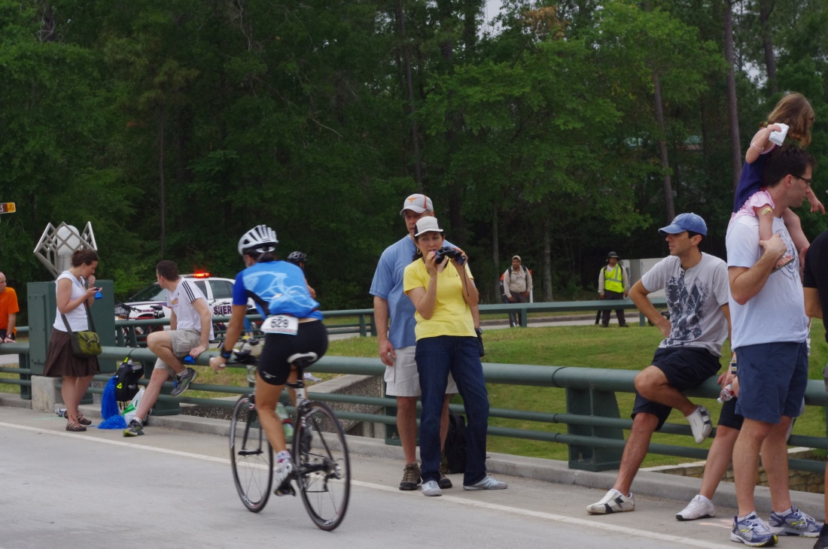

At that point I knew I had a few hours to kill, so I decided to go for a run. I didn’t really have a plan, but I went back to transition to drop my camera off at the car and started out along the run course. I kept following the course and the next thing I knew I had done one loop of the 3-loop course. The course was really interesting! Part of it was shaded and along a run path, and then you went into a really nice neighborhood along the canal. At that point the run was really hot, as there was no shade and you were running on white cement. Then the run took you through the downtown area (Market Street) and back out to the canal. Based on my time, I think my run was about 8 miles - they didn’t have the downtown part of the course set up yet so I ran by downtown and back to the car. I downed a drink, had 3 gel blocks, and decided to do it again. WOW! The second time it was really hot! It was hot the first time too, but now the sun was coming out and the wind died down and it was STEAMY! I kept thinking, “tell my athletes to grab the icy sponges”… “tell them to keep drinking” (unlike me)….. “don’t forget your salt”…… I got back to the car and grabbed a change of clothes. I went into the H.E.B. (grocery store) and used their bathroom for a “shower”. I changed clothes, grabbed another drink and my camera and headed out on the course just in time to see the pro women come in. And in amongst the pro women and very fast young studs, came Mike (5:14). He had (for him) a very fast transition, and after seeing him on the bike, I ran down the levy in time to catch him starting out on the run……

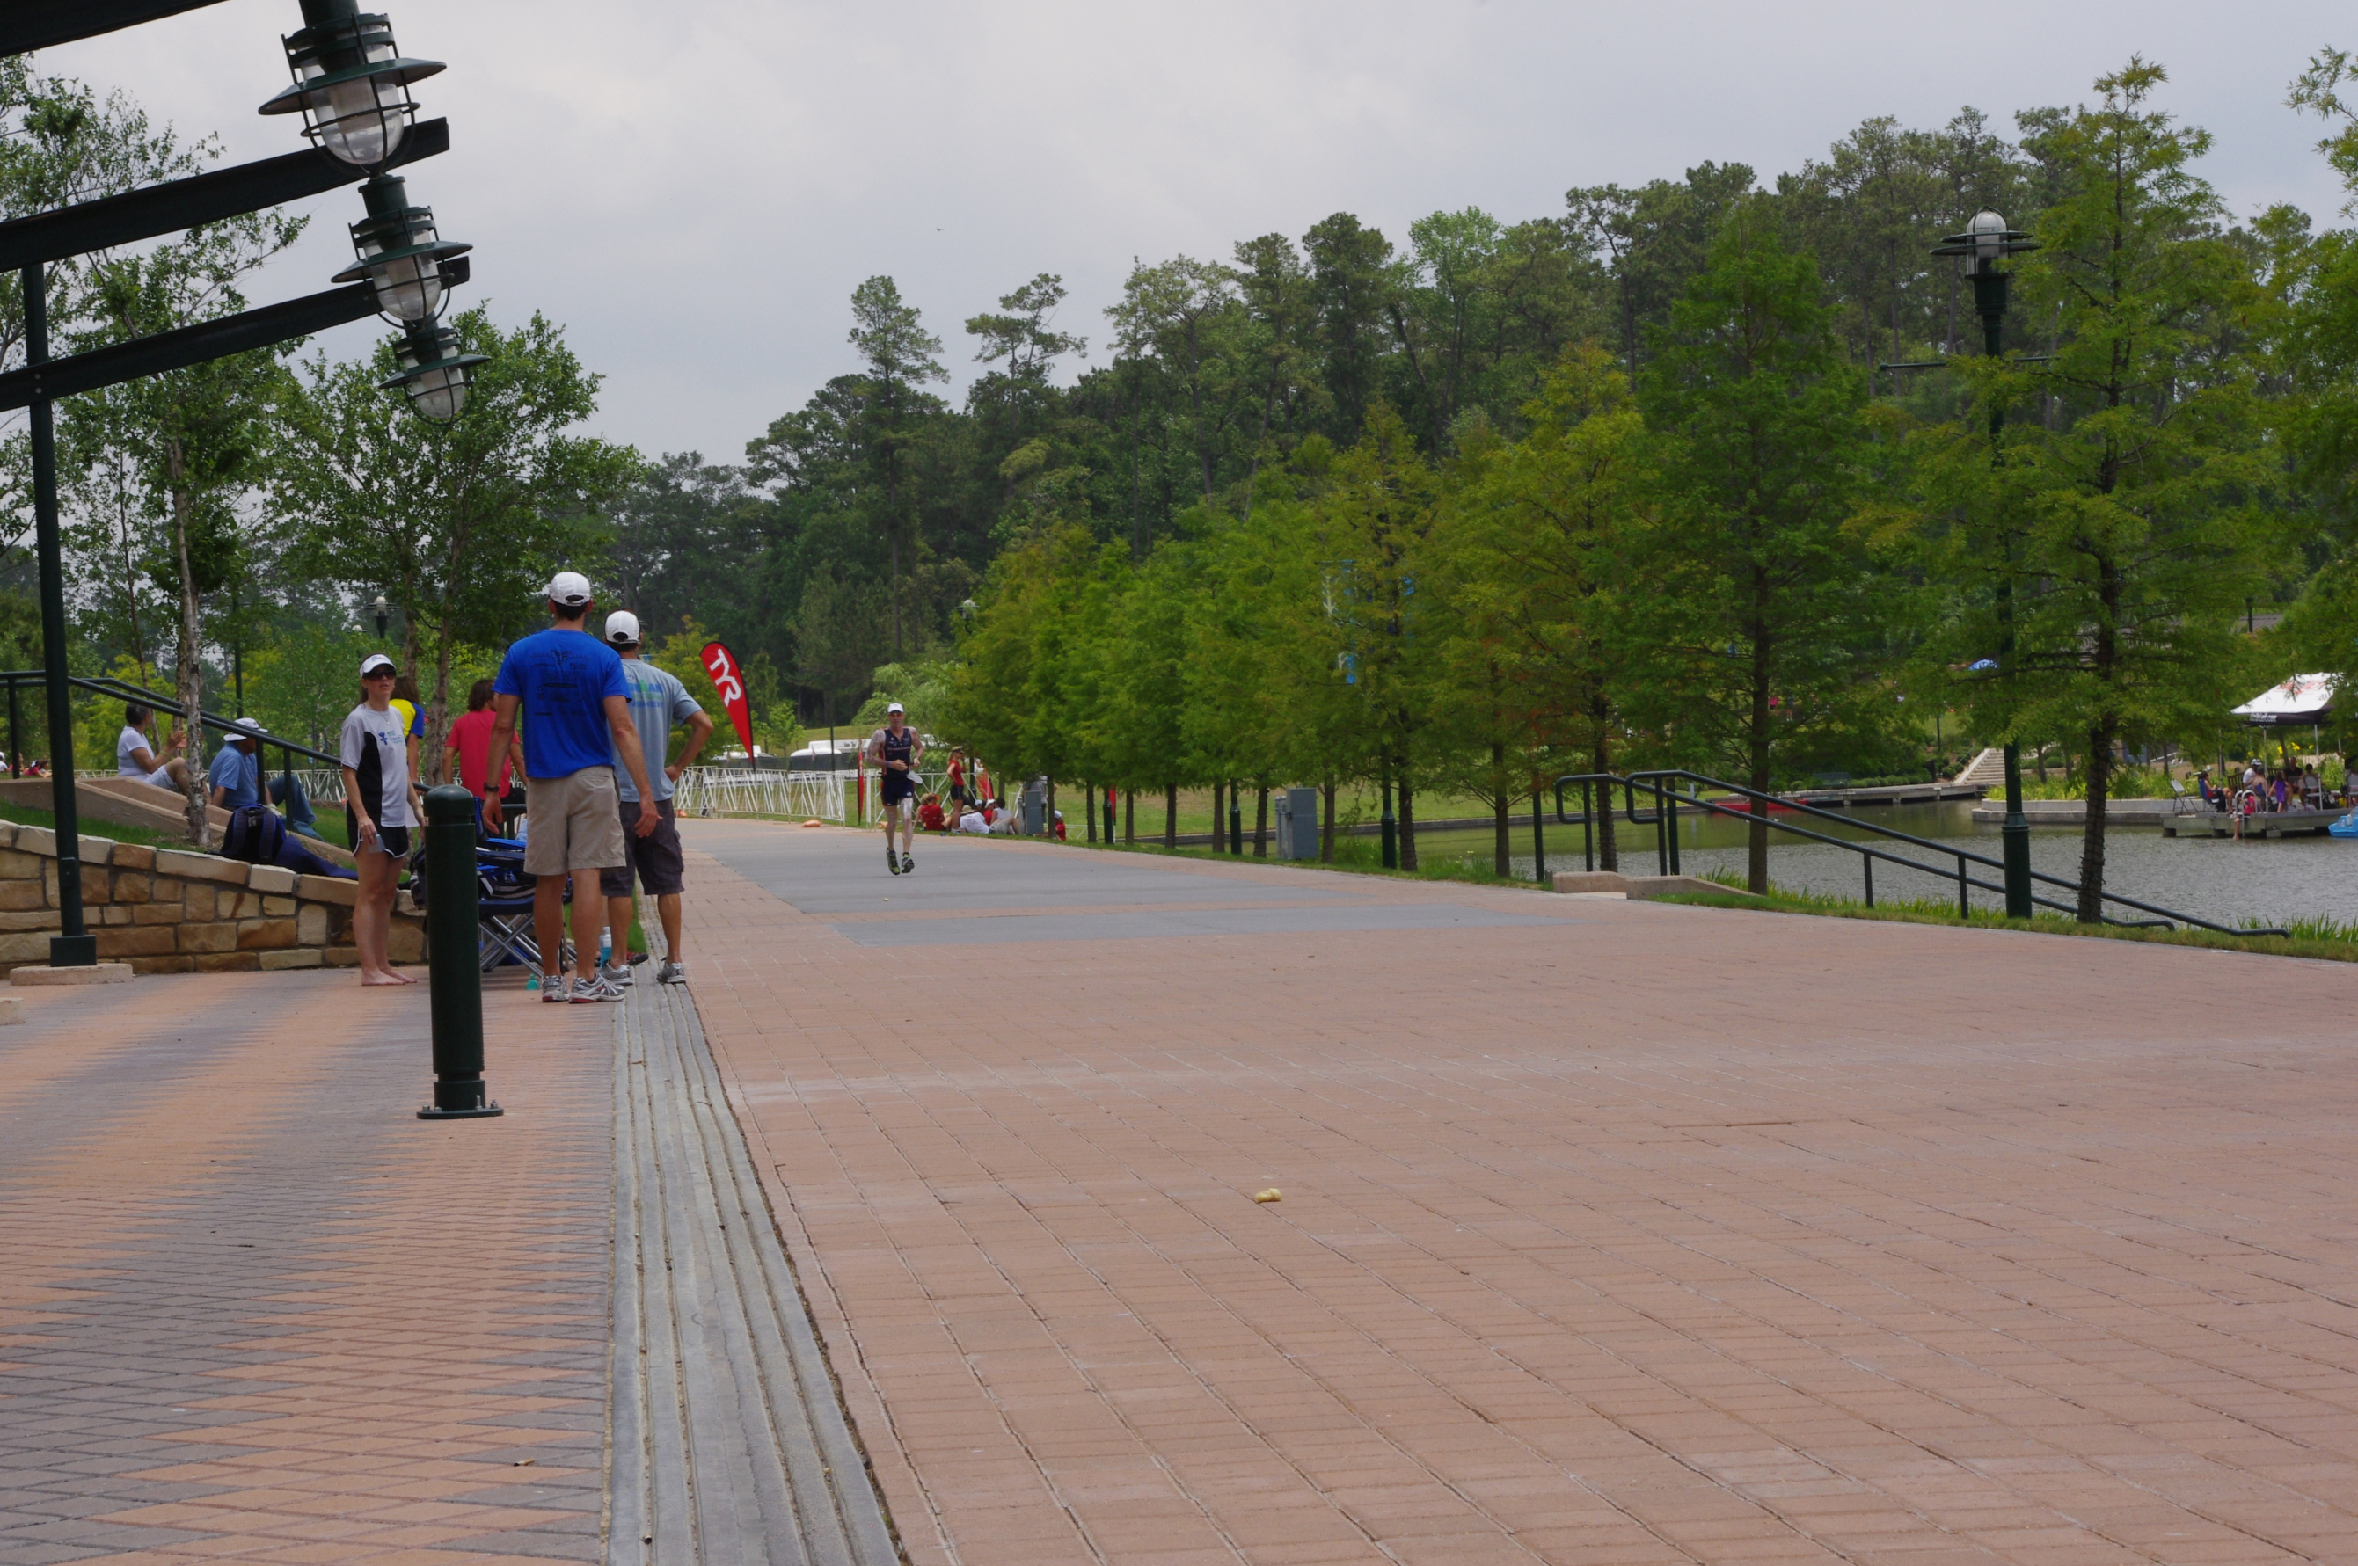

Chris Lieto had been in the lead for men until he dropped out after his bike. Eneko Llanos then was in the lead but one of our favorites, Tim O’Donnell was doing his first Ironman and was starting to run him down…..
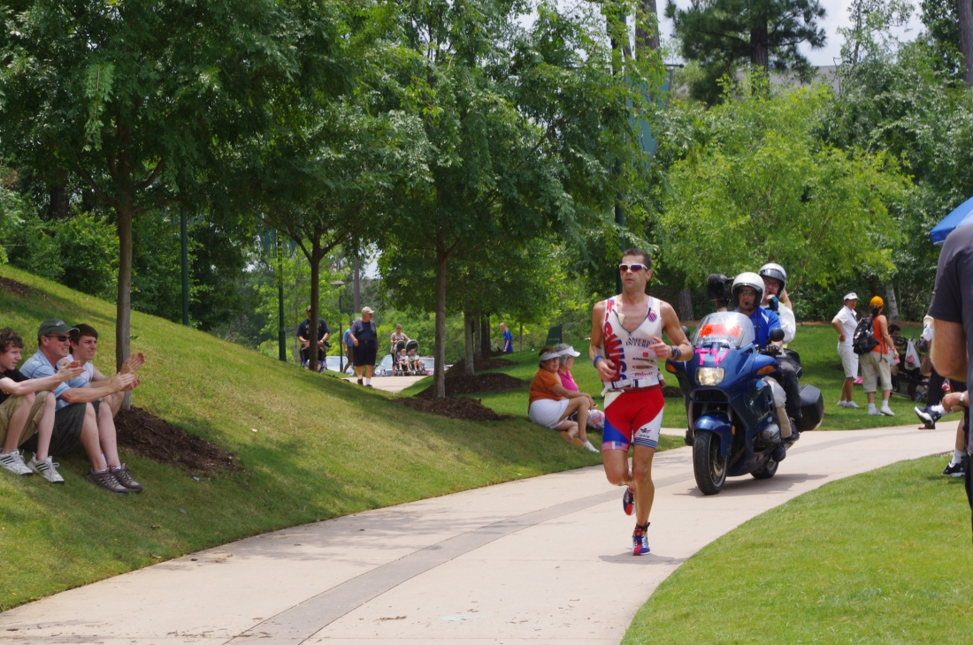

Of course, I’m not the only one who is a Tim O’Donnell fan. So is girlfriend (and IM World Champion) Mirinda Carfrae..

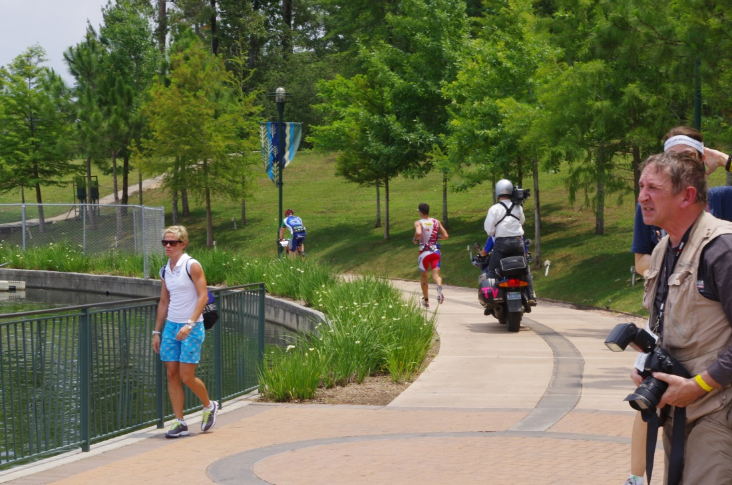

Downtown, the crowds were amazing! This is a great race for spectators; there is plenty to do while the athletes are out on the bike. But the spectators didn’t lose sight of the real excitement downtown that day and they stayed 10-deep well into the night ….

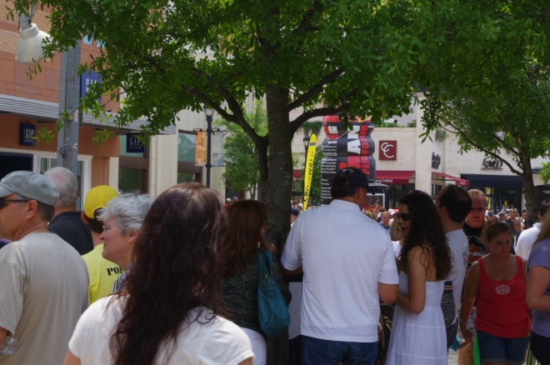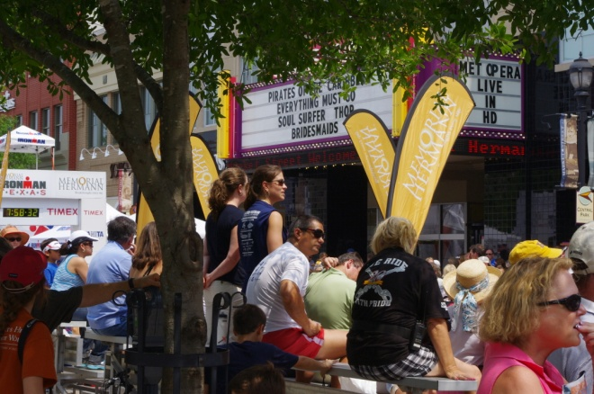

While I was at the finish area watching the pros come in I looked across the street and thought I recognized a friend and fellow coach from Massachusetts….. but that couldn’t be …. Cait would have told me …. “Hey! Jesse! Over here!” …
Jesse was in town for the weekend to check out the race and he also had a couple of athletes in the race (Dede Griesbauer and Jacqui Gordon).

We both continued to watch the pros come in and friends were texting me that Mike was still in first place in his age group but everyone was slowing down on the run (did I mention that it was really HOT?!). It seems that everyone who was crossing the finish line was being whisked off to 'medical' in a wheelchair.

I had seen Rob a couple of times on the run, Mike told me he had seen Christina and she was looking good, and Cait and my athletes back in Massachusetts were giving me updates on all their teammates.

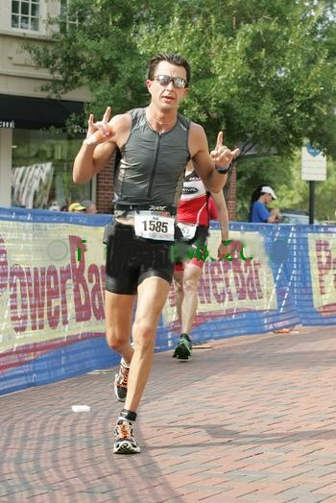

Tina's husband and daughter came up for the race and although I never hooked up with them, they managed to snap a couple of great shots of both Tina and Christina: (yup, Christina really hates race food)…….
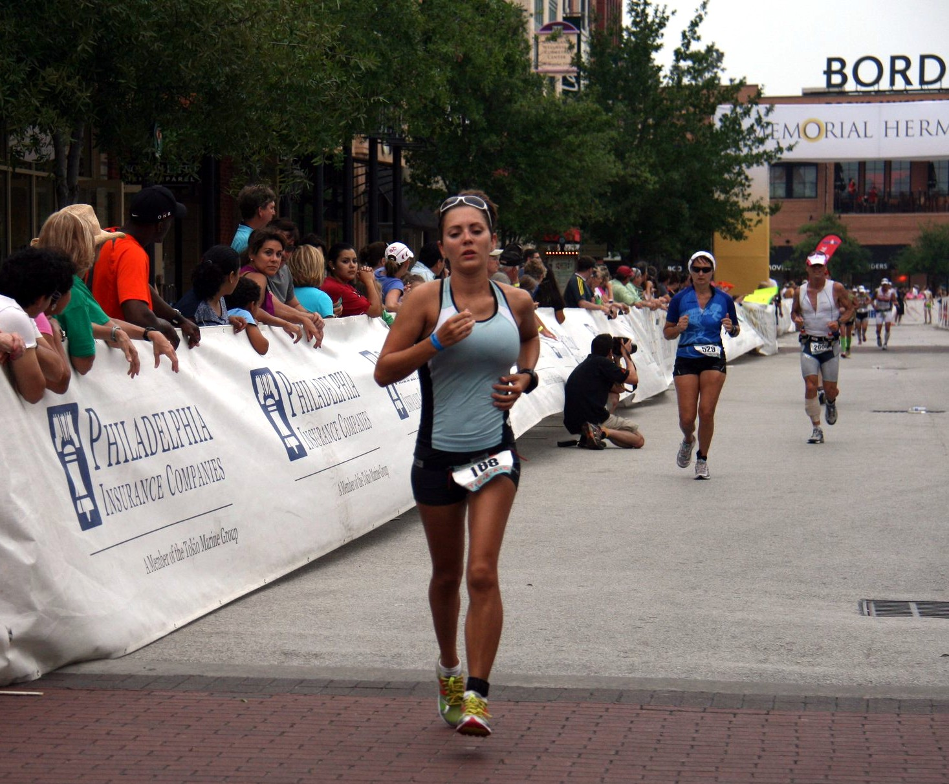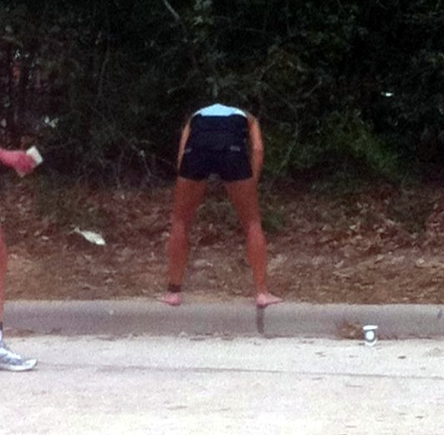

Just as I was starting to get nervous about Mike, I saw him coming around for the final loop of the run. He stopped to give me a kiss and said, “How am I doing?” I said, “Keep going, I think you are still in 1st”. Just as Mike was about to cross the finish line I heard Mike Riley say, “He’s 53 years old. He’s from the Woodlands. Doing his first Ironman is someone-who’s-name-is-not-Mike-Lamie”. Holy crap! Where is Mike? There he is! Oh my God – he beat that guy by a second!

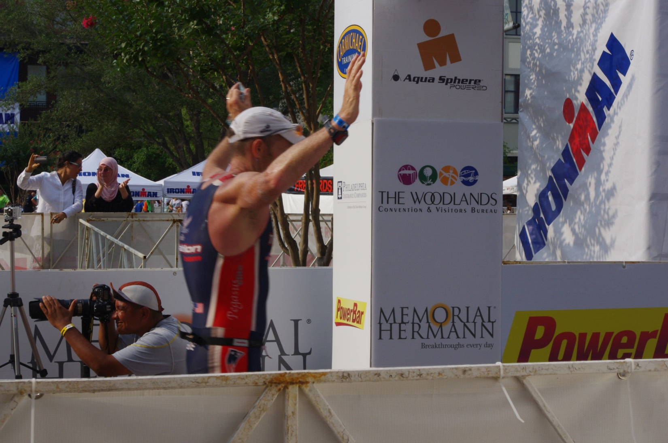

They whisked Mike off to the medical tent (that’s where they keep the Coke apparently), while Tim Walsh, Cait and I traded texts. It turns out that Mike had won by 5 minutes, and Mike Riley had called out the wrong name when Mike finished. Anyway ….. next up was Rob Botard, going 11:14 for his first Ironman ….(to the delight of his coach , his team mate, and his family!)

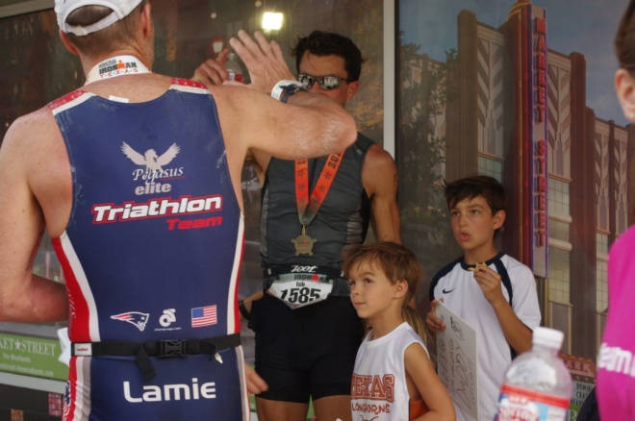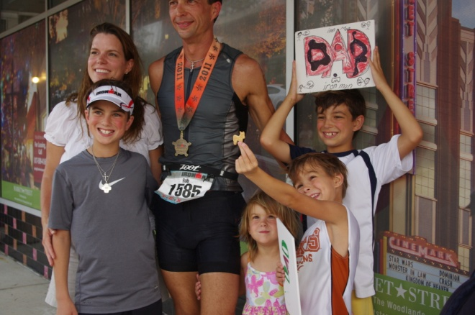

They say a picture is worth a thousand words, and I just love the look on Christina's face in this photo (also, look at the bored woman in the background! HA!) ……

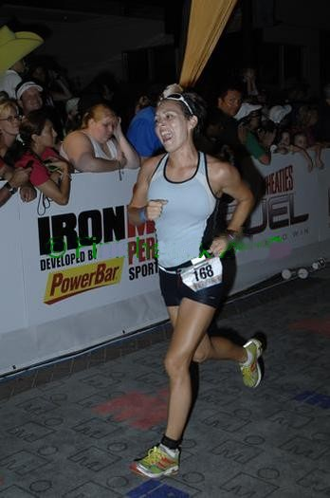

… and take a look at the expression on Tina's face in this picture!

I love my job anyway, but it's times like this that I feel like the luckiest person in the world. When I was growing up, I wanted to be an obstetritian. I thought it would be so great to spend my days bringing new lives into the world. And while I'd never take that kind of credit here, I am so lucky to be part of this amazing transformation that athletes go through when they are put to the test physically and mentally during Ironman.

Thank you Tina, Christina, Robert and Mike for letting me be a part of your day! 